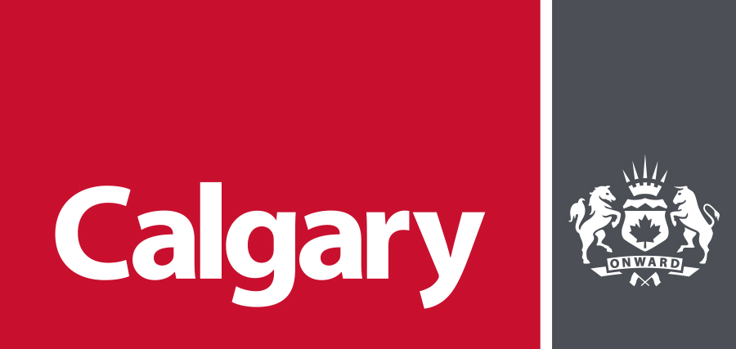
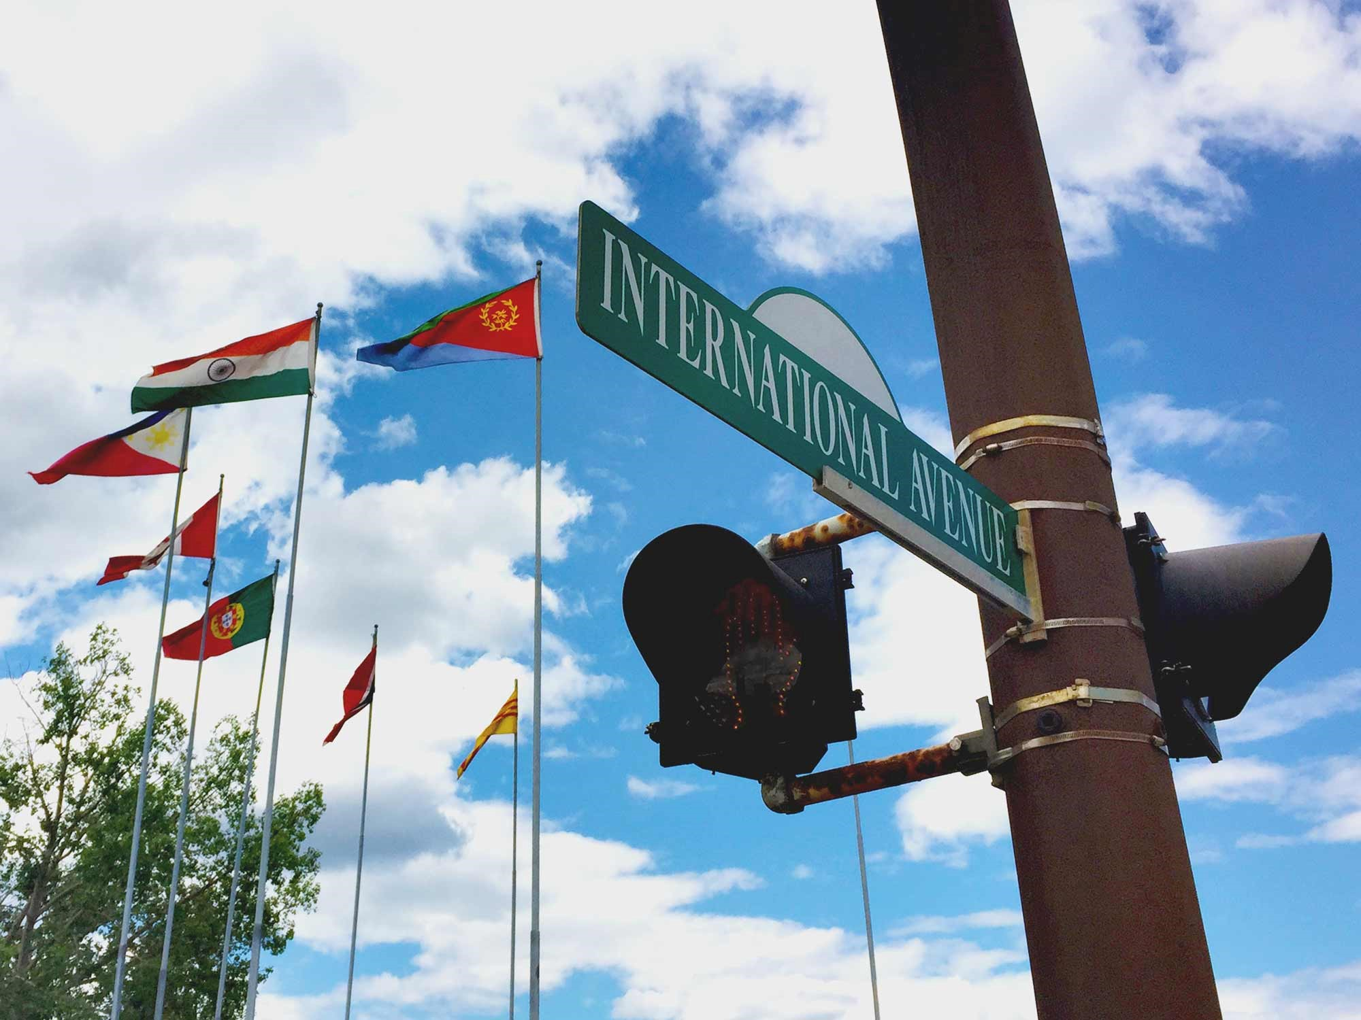
International Avenue Public Art Project
Call to Emerging Artists

International Avenue
Public Art Project
CALL TO EMERGING ARTISTS
This opportunity is open to emerging artists of all disciplines who are looking to expand their practice to the public realm. Individual artists or artist teams/collectives may apply.
The City of Calgary Public Art Program invites emerging artists or artist teams to submit qualifications to develop artistic concepts for International Avenue (17 Avenue SE, between 26 Street SE and Hubalta Road). Artists with ties to Calgary and this area of the city are encouraged to apply. Up to three artists/artist teams will be selected. The City will work with the successful artists to understand their practice and provide support and resources, including access to an Artistic Advisor, who is experienced in public art practice and can provide guidance, support, and expertise to help bring the concepts from vision to reality.
Based on past discussions with the local community, the desire is for the artwork to be a physical object along International Avenue, which can include (but is not limited to) installations/sculptures, multimedia, lighting, murals, street furniture, etc.

Artist Fee (Design only): $4,000 (not including GST) per project. Additional compensation for engagement and fabrication based on CARFAC fee schedules will be provided.

Fabrication budget: $21,000.00 CAD
Not including GST
Maximum, all inclusive

Application deadline: 5 pm MST
Friday, October 11, 2019

Target start*: November 2019

Target completion*: Summer 2020
*Timelines are based on Capital Funding, but may be negotiable.

Context

About International Avenue
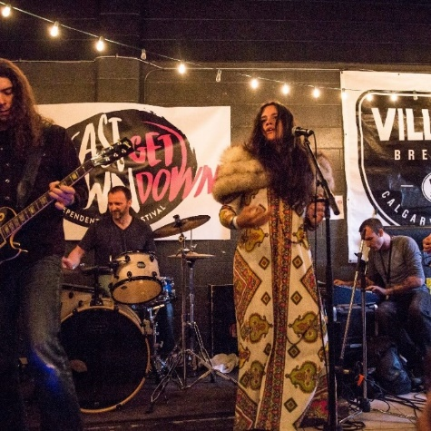
International Avenue is a vibrant business district located on 17 Avenue S.E. Over 425 businesses operate within this area, including restaurants and grocery stores featuring cuisine from around the world, and a wide range of other goods and services. International Avenue has become known as a cultural and culinary hub in Calgary, boasting some of the most authentic and charming restaurants in the city and a lively and continually growing arts and entertainment scene. The neighbourhoods surrounding International Avenue include Radisson Heights, Southview, Dover, Forest Lawn, Erin Woods and Penbrooke Meadows. Over a quarter of the residents in these areas come from immigrant backgrounds. Languages commonly spoken include Vietnamese, Tagalog, Arabic, Spanish, Cantonese, and English.
In 2018, The City of Calgary opened the MAX Purple transit route which connects International Avenue and the surrounding communities with East Hills, Inglewood and Downtown. This rapid transit service is part of ongoing efforts to improve connectivity and livability in this area of the city.

International Avenue recently won an urban design award for the Area Redevelopment Plan and has been recognized for its successful integration of transit within the community.

Available sites for artwork
International Avenue is a busy pedestrian, transit and motorist corridor, and therefore there are limits to where art can be incorporated. Ten potential sites have been identified by the International Avenue BRZ and the Transportation Department, and Public engagement is currently underway to refine which sites make the most sense from the public’s perspective. Sites will be discussed in more detail once the successful artists/artist teams are hired. To view the ten potential sites, please visit www.engage.calgary.ca/InternationalAvePublicArt
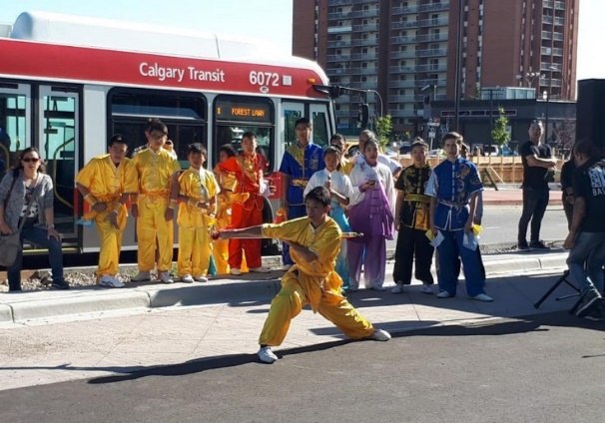
Photo courtesy of International Avenue BRZ

THE PROJECT

Background
This call is part of the International Avenue Public Art initiative, and is intended to provide a number of opportunities for artists with ties to Calgary and the local area to contribute to the vibrancy of this corridor. We are seeking up to three emerging artists or artist teams who are interested in evolving their practice and applying it in the public realm. Artists or artist teams will be tasked with creating a design-only, temporary public artwork. Based on previous discussions with the local community, the desire is for the artwork to be a physical object, which can include (but is not limited to) installations/sculptures, multimedia, lighting, murals, street furniture, etc. The artists will have access to an Artistic Advisor who will provide support and resources for the duration of the project, including guidance and expertise on developing concepts for the public realm.

Goals
This project will:
- Create a sense of place in the community
- Be visually or audibly interesting
- Engage pedestrians, cyclists and motorists
- Be reflective of the local community and the feedback collected through engagement

Public engagement
To ensure the project is reflective of the Calgary area and its peoples, the artist or artist team will be required to participate in a series of engagements with the public. Engagement will be planned collaboratively with the artists and coordinated by The City of Calgary.
At the concept development phase of the project, the artist or artist teams will be expected to describe how the public engagement relates to their concept.
The first phase of public engagement is currently underway, and focused on determining the best places to enjoy and interact with art along International Avenue. The second phase of engagement will be done in collaboration with the artists, and will include a deep look at the community, and the stories of the people who live there.

Collaboration with City staff
To ensure the public art project meets project goals and requirements of the Public Art Program, the artist or artist team will work closely with Public Art Program staff as well as other stakeholders, such as engineers, conservators, safety advisors as applicable.

ABOUT CALGARY
Calgary is located in the rolling foothills of southern Alberta, where the high plains rise into the foothills of the Rocky Mountains.
The Calgary area where the Bow and Elbow rivers meet is a place of confluence where the sharing of ideas and opportunities naturally come together. Indigenous peoples have their own names for this area that have been in use long before Scottish settlers named this place Calgary. The Métis call the Calgary area Otos-kwunee. In the Blackfoot language, they call this place, Moh-kins-tsis. The Stoney Nakoda Nation refer to the Calgary area as Wîchîspa Oyade and the people of the Tsuut’ina nation call this area Guts-ists-i.¹
We would like to acknowledge that this project will be located on the traditional territories of the people of the Treaty 7 region in Southern Alberta. This includes: the Siksika, Piikani, and Kainai collectively known as the Blackfoot Confederacy; the Îethka Nakoda Wîcastabi First Nations, comprised of the Chiniki, Bearspaw, and Wesley First Nations; and the Tsuut’ina First Nation. The city of Calgary is also homeland to the historic Northwest Métis and to Métis Nation of Alberta, Region 3. We acknowledge all Indigenous urban Calgarians, First Nations, Inuit, and Métis, who have made Calgary their home.¹
One of the guiding principles of the Public Art Program will be to share, and provide a voice to, the historical context of Calgary; honour that information, and include and embed it in the work going forward. To learn more, watch the video: Calgary Foundation Land Acknowledgement (Full) on YouTube.

Calgary at a glance:
- Total population: around 1.27 million.²
- Geographical size: 848 square kilometres.⁵
- A diverse city: Calgary is home to “more than 240 different ethnic origins, and is ranked third in proportion of visible minorities in Canada”⁴ with a visible minority population of 33.7%.⁴
- A liveable city: Calgary is listed as the fourth most liveable city in the world, and is the top-ranking city in Canada.³
- A young city: Calgary has the youngest population of major cities in Canada – the median age is 36.9 and 70.2% of the population is 15 to 64.⁴
- A multi-lingual city: Calgarians identified close to 140 languages spoken as their first language.⁴
- A destination city: Calgary was listed at #20 for the New York Times’ 52 Places to go in 2019.⁶
- Moh'kinsstis Public Art Guiding Circle
- 2018 Civic Census
- The Economist: The Global Liveability Index 2018
- Calgary Economic Development: Demographics
- Calgary Economic Development: Our location
- Tourism Calgary Visitor Guide

KEY DATES
Submission deadline: 5 pm MST on Friday,
October 11, 2019.
Late submissions will not be considered.

Shortlist interviews: October 2019

Public engagement: November 2019

Early concept development: November 2019 - February 2020

Detailed design & fabrication: Spring 2020

Project completion: Summer 2020

*Timelines are based on Capital Funding, but may be negotiable.

BUDGET
Shortlisted artists or artist teams will be paid $4,000 for concept development. Artists will also be compensated based on the 2019 CARFAC fee schedule for their time spent engaging with the public, and consulting during fabrication and installation.
The all-inclusive, maximum fabrication budget will be $21,000.00 CDN (not including GST).
The artist/artist team will work with the artistic advisor to ensure the concept that is developed can be fabricated within the allocated budget.
For object-based works, the total fabrication budget includes:
- Engineering fees
- Materials
- Fabrication
- Transport of any materials
- Installation
- Contingency (10-15% depending on the project)

HOW TO APPLY
Artists submissions must include:
- Letter of Interest (500 words maximum) should include, but is not limited to:
- Why this opportunity appeals to you.
- How your background and practice will contribute to this project.
- Your knowledge of or connection to Calgary and the project’s place.
- Experience working to a schedule and budget.
- Experience collaborating with others and engaging stakeholders/the public.
- Curriculum Vitae (500 words maximum)
  - Include past work experience as it relates to creating art.
  - Include current contact information including e-mail address, telephone number and mailing address.
- Images (Maximum of 10 images)
  - Up to 10 images of past work
  - Include a brief description of the commission, credit to other collaborators, title and date of the work.
- Submission Form
  - Complete the submission form attached to this document.

How to submit
- Email publicart@calgary.ca and attach all the required documents listed above.
- Submissions must be less than 10 MB in total.
- Submissions are accepted in electronic form only and compatible with PC.
- Incomplete submissions will not be accepted.
Please do not submit a proposal.

Artist teams
If applying as a team:
- Identify the project lead and team members;
- Include CVs for each team member
- Only one letter of intent is required
- Describe how the team will be structured including the role of each team member
- Fair compensation for teams will be determined in consultation with City of Calgary Pubic Art staff prior to the start of the project.

References
If selected, shortlisted artists will be asked to provide a minimum of two professional references, including their name, address, e-mail and telephone number.

SELECTION PROCESS

Step 1 - Shortlisting
All eligible submissions are reviewed by a selection panel consisting of arts professionals, community members and a City business unit representative. The selection panel will shortlist artists or artist teams based on how their submissions meet the following evaluation criteria (rated out of a possible total 100 points):
- Letter of Interest - 70 points
  - Why this opportunity appeals to the artist; how the artist’s background and practice will contribute to this project – 25 points
  - Knowledge of or connection to Calgary and/or the project’s place – 15 points
  - Willingness to learn, evolve current practice and incorporate feedback in concept development – 15 points
  - Quality of past projects – 15 points

- Curriculum Vitae/Images - 30 points
- Demonstrated, relevant experience in completing projects and managing budgets – 10 points
- Demonstrated artistic excellence in contemporary art practice – 20 points

Step 2 – Interviews
Shortlisted artists or artist teams will be invited to an in-person interview with the selection panel. Up to 3 artists or artist teams will be selected to proceed with concept development based on the following evaluation criteria:
- Interview – 50 points
  - Demonstrated flexibility of practice; responsiveness to contextual opportunities – 25 points
  - Demonstrated understanding of the project and its context in the community – 25 points

- References – 20 points
  - Demonstrated ability to collaborate with project teams - 10 points
  - Demonstrated ability to deliver a project on time and on budget - 10 points

- Curriculum Vitae / Images - 30 points
  - Quality and relevance of overall past work – 30 points

Public Art Process

Early concept development
The successful artists/artist teams will take part in community engagement events and develop preliminary concepts inspired by their time in the community. In addition to the artist fee for concept development, artists will also be compensated for their time spent on public engagement based on the 2019 CARFAC fee schedule. An Artistic Advisor will be available to provide advice and guidance throughout the process and will help artists navigate through all stages of the process, including concept development and refinement, managing budgets, and fabrication requirements.
During early concept development, artists will have the opportunity to present their preliminary concepts to the selection panel. The intent of this is to ensure artists are set up for success and can proceed confidently with refining their concepts. The selection panel will look at concepts through the following lens:
    - Contextual Relevance – Is the concept relevant to the location and is it appropriately scaled for the space/environment.
    - Feasibility – Will this concept work in the real world, and can it be fabricated for the allotted budget? Will it meet safety and durability requirements?
Constructive feedback will be provided to artists for consideration in the development of their concept.

Concept refinement & fabrication
Artists or artist teams will further refine their concept through the detailed design stage. Designs will be vetted with engineers, conservators, and other subject matter experts to ensure they meet safety and technical requirements for the public realm.
Artists will be encouraged to be part of the fabrication and/or installation process as a learning and development opportunity, and will be compensated for their time based on the 2019 CARFAC fee schedule.

ARTWORK PARAMETERS
The City of Calgary requires that artist’s work (whether object-based, non-object based, residency, or social practice) must adhere to the following parameters:
- The artist must guarantee that the artwork is original and does not violate the copyright of any other person.
- The artist must ensure they do not appropriate other cultures.
If producing an object, artwork parameters include:
- Safety:
  - Artwork must not pose a risk of injury to the public, e.g. sharp points, slip hazards, etc.
  - Artwork must not create opportunities for accessing areas restricted to the public.
  - Artwork must meet any applicable regulatory requirement or standards, e.g. Alberta Building Code, Noise Bylaws, etc.
  - Artwork must meet fire codes with respect to flammability, as applicable.
  - Artwork must not interfere with the operation and serviceability of the location/nearby buildings.
  - Artwork must not interfere with any accessibility requirements of the road right-of-way, sidewalks, etc.

- Durability:
  - If developing a physical object, artwork must be constructed of durable, permanent materials, and designed to last approximately 5 years.
  - Artwork must be low maintenance and sustainable.
  - Artwork must be vandal resistant.
  - Artwork must be designed to be accessible for maintenance.
  - The artwork must be able to withstand sunlight exposure, drastic variations in temperature (-40 to +40 degrees Celsius), physical environment risk and countless audience interactions.

- Non-object artwork (not applicable for this call):
- If the artistic practice does not include object-based artwork, additional considerations and parameters will be identified in consultation with City of Calgary Public Art staff.

CONTRACT

Scope of work
Upon selection, the successful applicant artist or artist team will complete a Scope of Work document that defines: deliverables required for each milestone, timing for milestone payments, and amount of milestone payments.
The successful applicant will invoice The City of Calgary with terms of Net 30 days for payment.

Artist Agreement
The selected artists and artist teams will be required to sign an Artist Agreement with The City of Calgary prior to confirmation of award.
The document is available online at: www.calgary.ca/bids (click on Supply Management Terms and Conditions.

Insurance
Upon selection, the successful applicant artists and artist Teams will be required to provide proof of appropriate insurance (in this case, $2M) prior to confirmation of award.

THE PUBLIC ART PROGRAM
The City of Calgary’s Public Art Program is committed to great public art that impacts Calgary’s urban landscape, and transforms the way Calgarians see, think and experience the city around them.
Established in 2004, the Public Art Program ensures the allocation of 1% of all capital Upgrade and Growth projects over $1 Million to public art.
The scope of public art opportunities, as outlined in the Public Art Policy, includes discrete, semi-integrated, integrated and temporary works, and allows for artists on design teams, community-based public art, and special projects such as artist residencies.
For more information about the program, visit www.calgary.ca/publicart.

LEGAL

Commissioner
The commissioner for this project is:
The City of Calgary
Box 2100, Station M, Calgary, AB, Canada T2P 2M5
Mail code #63
Contact for questions: publicart@calgary.ca.
How to submit application: email publicart@calgary.ca.

Public tenders
There will not be any public opening of tenders.

No cost
There is no cost to the applicant to submit an application.

Language
Applications must be submitted in English.

Cancellation
The City may, at its own discretion, stop or suspend the performance of the Services at any time. When the Artist is not in default, The City shall reimburse the Artist as deemed appropriate by The City.

SUBMISSION FORM

Name

Address/City/Province/Postal Code

Phone/email/website (if applicable)

How did you hear about this call?

SUBMISSION CHECKLIST:
☐ Letter of interest ☐ Curriculum Vitae ☐ References ☐ Images ☐ Submission form

